TASK ON JENKINS-2

Configure 2 slave machines in Jenkins master.

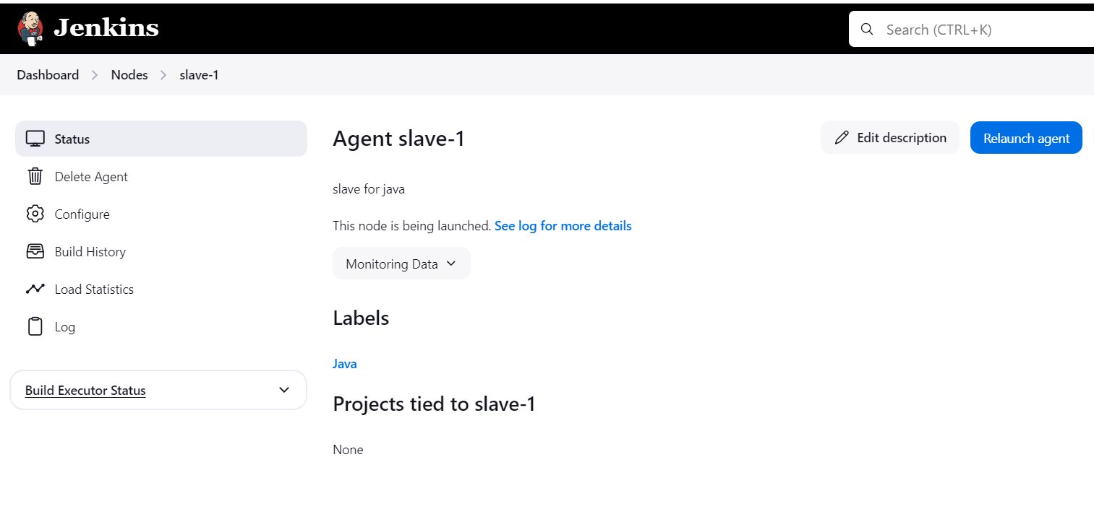

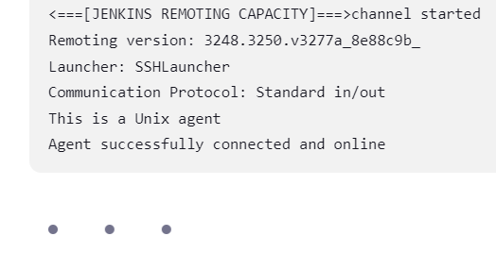

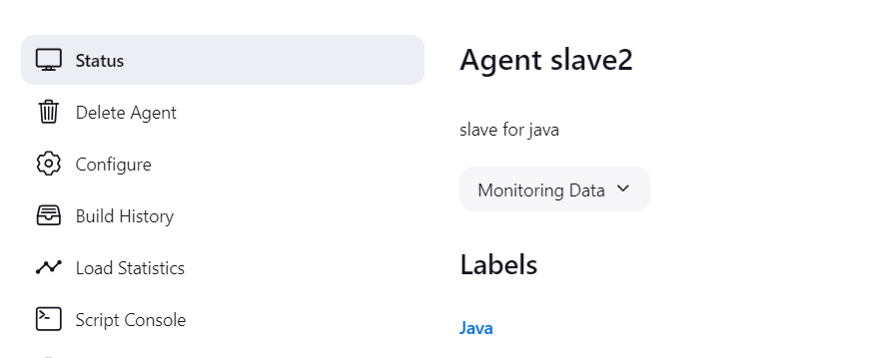

Configure webhooks to Jenkins job.

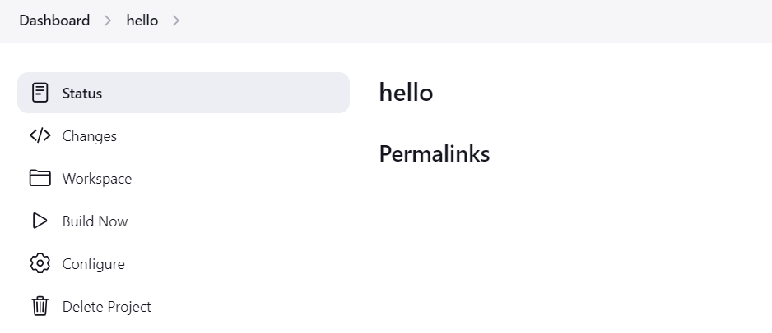

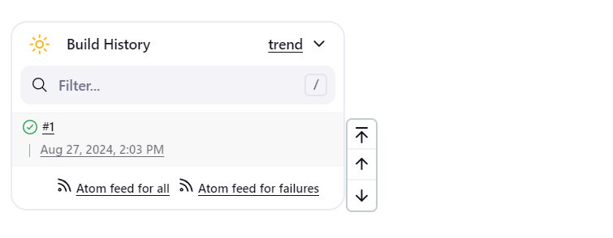

Configure poll scm and build periodical options in jenkins job.

**Configure build periodical options in jenkins job.**

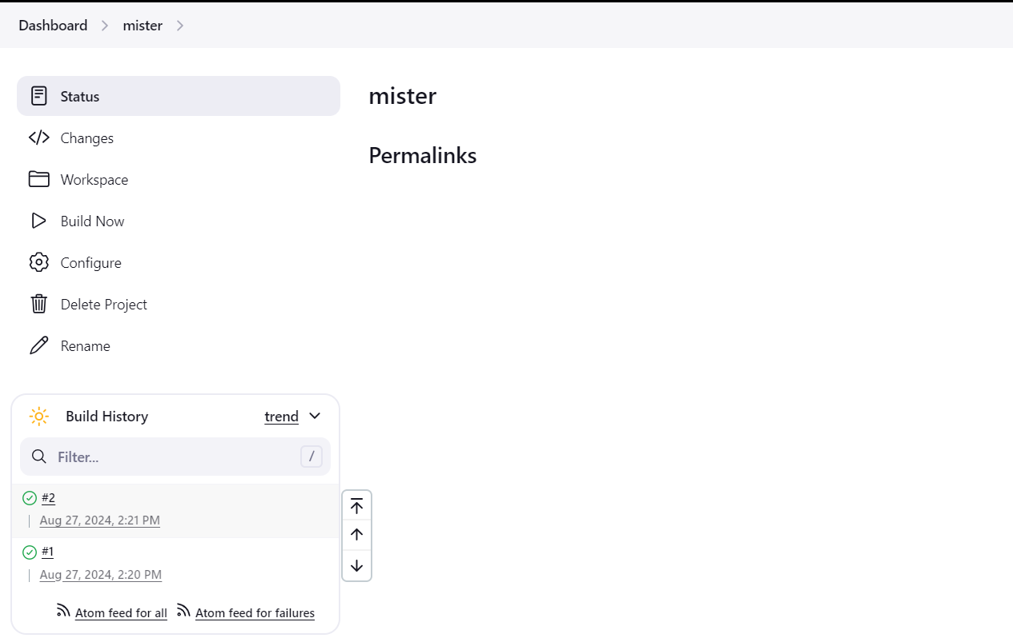

**Configure poll scm options in jenkins job.**

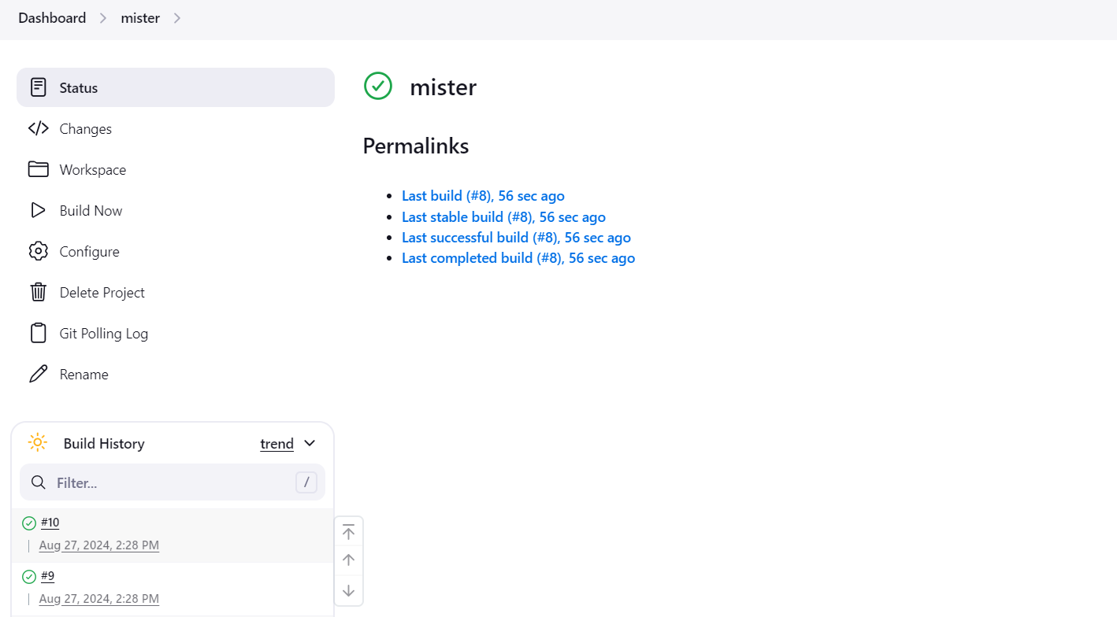

Take backup of Jenkins server by using bash script.

**#!/bin/bash  
# VariablesJENKINS_HOME="/var/lib/jenkins"  # Adjust this path according to your Jenkinsinstallation# Timestamp for backup filesTIMESTAMP=$(date +"%Y-%m-%d-%H-%M-%S")BACKUP_DIR="/backup/jenkins-backup-$TIMESTAMP"mkdir -p "$BACKUP_DIR"# Backup Jenkins Home directoryecho "Backing up Jenkins home directory..."sudo cp -r "$JENKINS_HOME" "$BACKUP_DIR/"# Backup Jenkins system configurations (optional)# Example: backing up Jenkins plugin configurationsecho "Backing up Jenkins plugin configurations..."sudo cp -r /var/lib/jenkins/plugins "$BACKUP_DIR/"# Compress the backup directoryecho "Compressing backup files..."sudo tar -czvf "/backup/jenkins-backup-$TIMESTAMP.tar.gz" "$BACKUP_DIR"# Clean up temporary backup directoryecho "Cleaning up temporary files..."sudo rm -r "$BACKUP_DIR"echo "Jenkins backup completed: /backup/jenkins-backup-$TIMESTAMP.tar.gz"**

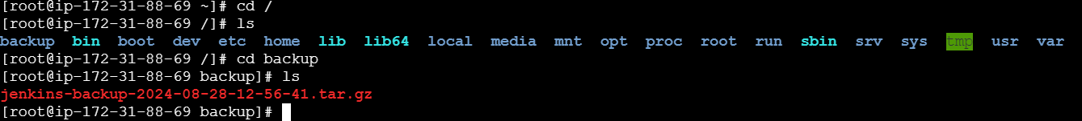

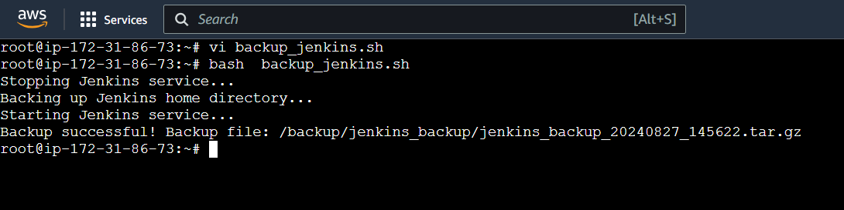

**Setup a new Jenkins server and dump the backup taken in the backup of task4**

